**Petroleum Projects**

**Existing Projects**

**Kutubu Oil Project**

Papua New Guineas first commercial oil project. Discovered in 1986 in the Southern Highlands Province.

Commercial production commenced in 1992 with maximum production of 139,000 bbls/day in 1993.

Production has since declined and is now producing at an average of 30,000 bbls / day.

Projects consists of oil producing wells from the Iagifu-Hedinia, Usano and Agogo fields , a Central processing facility , a 265 kilometre export pipeline to the coast and a marine loading terminal in the Gulf of Papua (Kumul Terminal). The pipeline operates under Pipeline Licence 2 (PL-2), while the oilfield operates under Petroleum Development Licence 2 (PDL-2)

The Project is operated by Oil Search Limited (60.05%) in Joint Venture partnership, with Ampolex (PNG Petroleum) Inc and Merlin Pacific Oil Company (14.52%), Merlin Petroleum Company (18.69%) and Petroleum Resources (Kutubu) Ltd (6.75%).

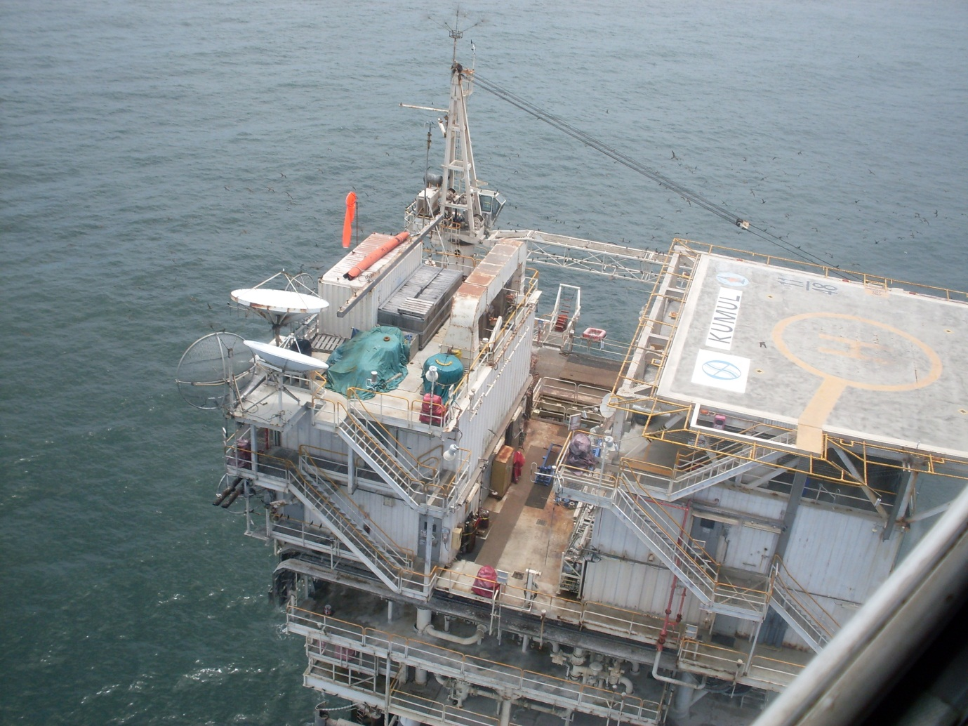

*Kumul Terminal , Gulf of Papua*

**Moran Oil Project**

Located in the newly established Hela Province, The Moran Project comprises of three license areas; PDL 2, PDL 5 and PDL 6 which is collectively known as the Greater Moran Unit.

First discovery was made in 1996 in PDL 2. Commercial production commenced in 1998 with initial production at an average of 45 000 bbls/day. Moran 4 located in PDL 5 (PPL 138) commenced production in April 2000. In 2002, a unitized agreement was signed between licensees of PDL 2 and PDL 5 resulting in the Central Moran Project.

In late 2003 North-west Moran (PPL 219) was discovered. In 2006 all Joint Venture partners in PDL2, PDL5 and PPL219 establish a single Greater Moran Unit across the Moran and NW Moran fields. Petroleum Development License for PPL 219 was granted in 2008 resulting in PDL6.

Production has since declined and is now producing at an average of 13,000-15,000 bbls/ day

Oil Search (PNG) Limited is the Operator of PDL-2 and the Moran Unit.

|  |  |
| --- | --- |
|  |  |

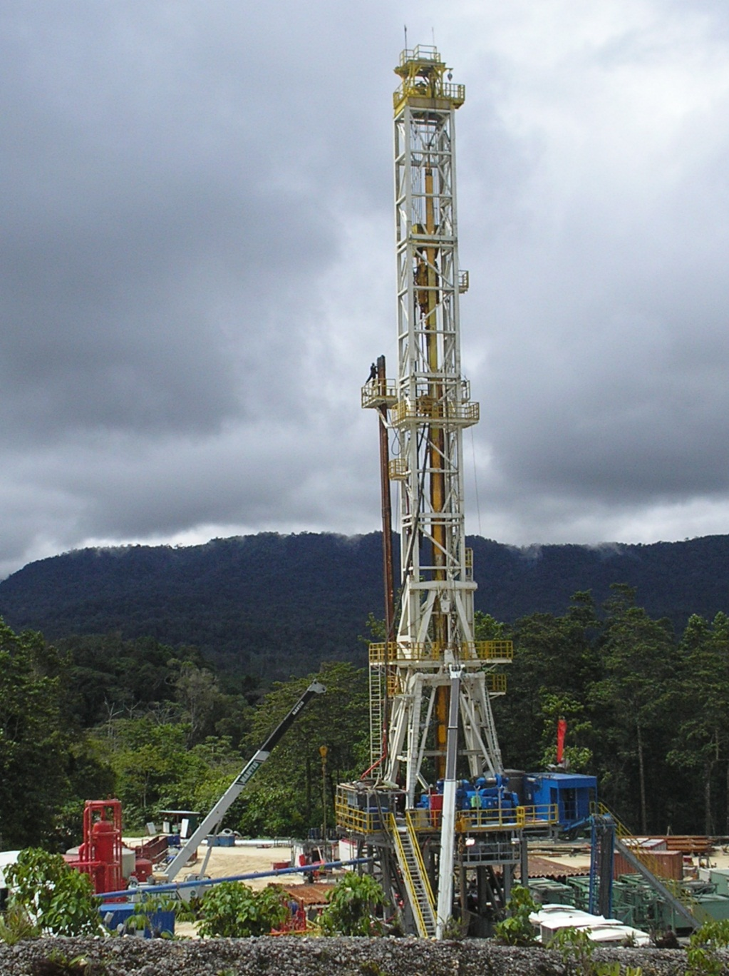

*OSL Rig 104 Moran Well Site*

**Gobe Oil Project**

Located in the Gulf and Southern Highlands Province, Gobe Oil Projects comprises of three discoveries; South-east Gobe discovered in 1991 and Gobe Main in 1993 and Gobe 3X blocks

The Gobe Main field is wholly located within Petroleum Development Licence 4 (PDL 4), while SE Gobe straddles the boundary of PDL 4 and adjoining PDL 3. The Gobe 3X block is in PDL3.

Commercial production commenced in 1998 .Production declined since and is now producing at an average of4,000- 5,000 bbls/day.

Oil Search Limited operates the Gobe Main and SE Gobe fields and is operator of PDL 4 as well as PDL 3.

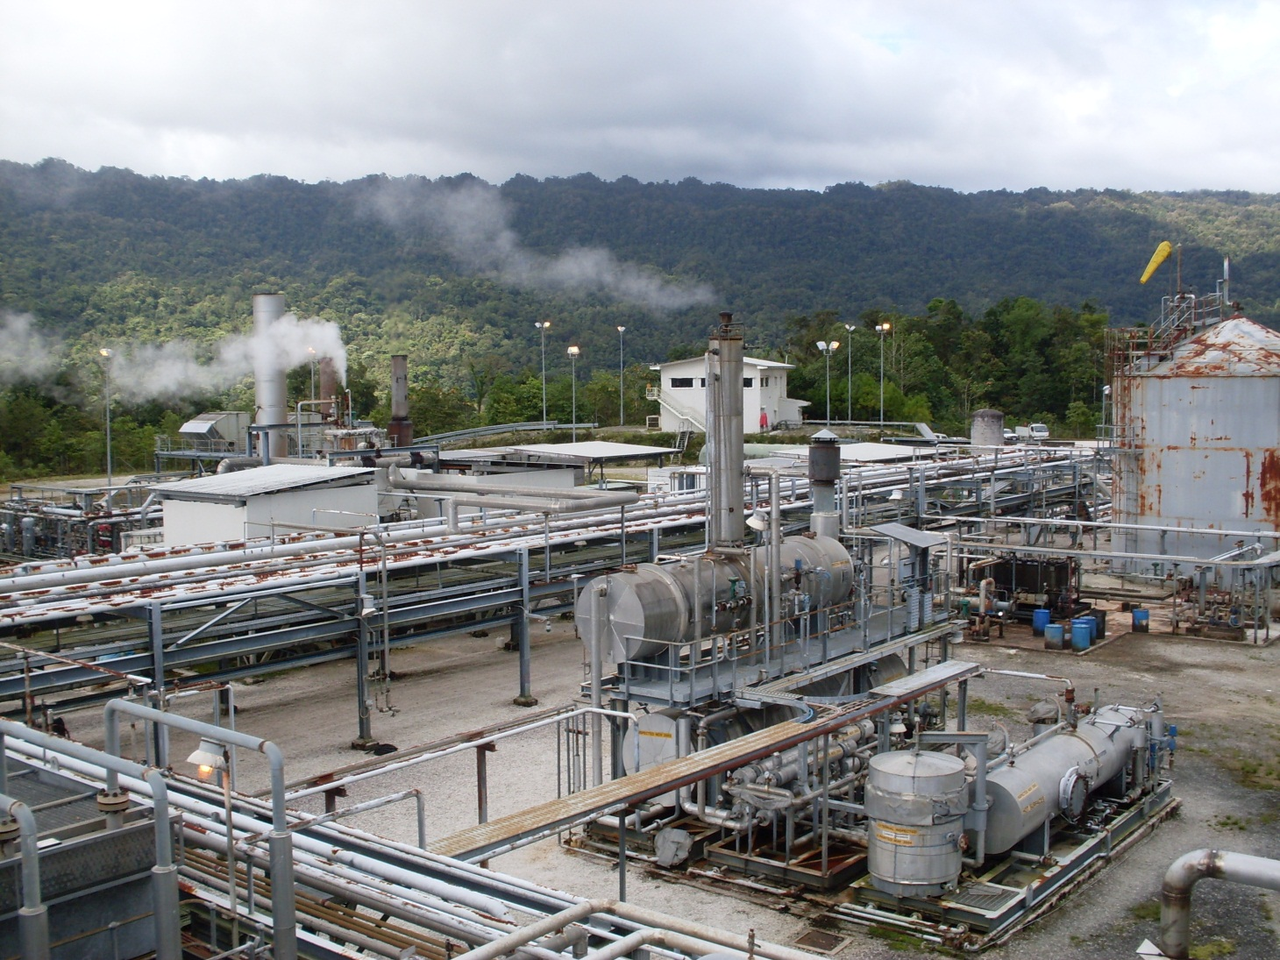

*Gobe Processing Facility*

**South-east Manada Oil Project**

Located in Hela Province, approximately 10 kilometres north-west of Kutubu in PDL 2. South-east Manada was discovered in 1991. Commercial production commenced in 2006 with an initial production 3000 bbls/day on average.

Production has since declined and is now producing at an average of

60-100 bbls / day.

The Project Operator is Oil Search Limited (72.26%) in Joint Venture partnership with Merlin Petroleum Company (19.84%)and Petroleum Resources Kutubu Ltd (7.90%).

**Hides Gas to Electricity Project (GTE)**

Located in the Hela Province and utilizing Gas from the Hides gas fields .

The Hides GTE project consists of a pipeline connecting the Hides 1 and Hides 2 wells to a small gas conditioning plant at the Hides Production Facility.

An average of 13-15 mscf/d is supplied to Pogera for electricity.

The gas is sold under a long-term gas supply contract. As of 2011 a new agreement was executed to continue supplying for the next 15 years.

Oil Search Limited is the Operator and owner of the Hides Gas to Electricity Project.